# Home Work #7

*Chapter 10* *Computer Analysis of Decision Trees and Sensitivity Analysis – Small Problems Using Precision Tree Software*

## Q1

### The Tree

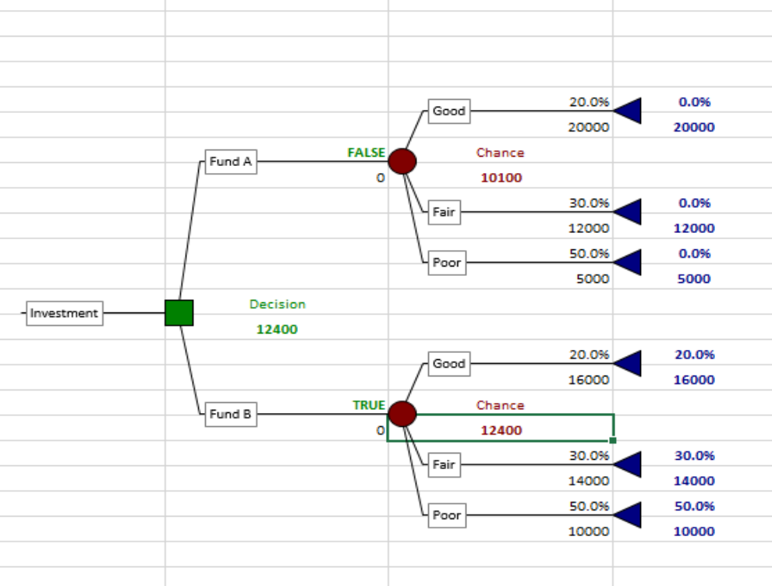

Tree Q1

### The Optimal Path

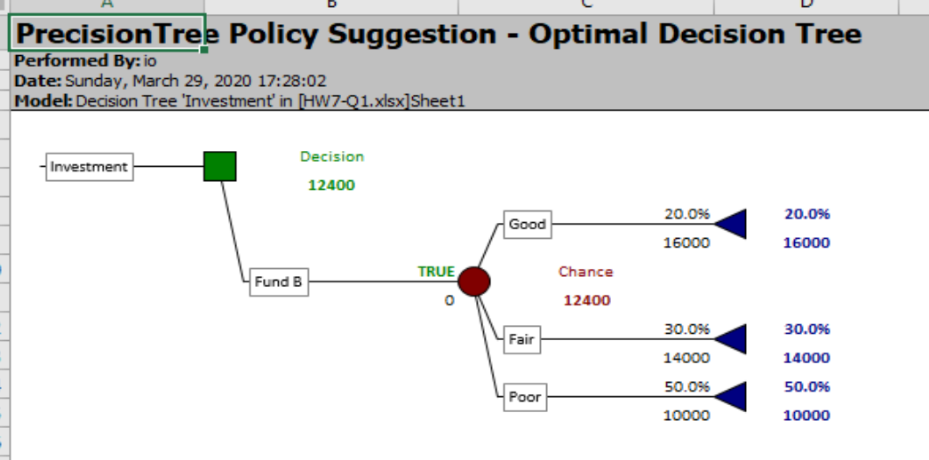

Optimal

### Sensitivity

The analysis is: until the value of the portfolio is 31.5K, it is when the return must be at least 21.5K the Fund B is still the best option.

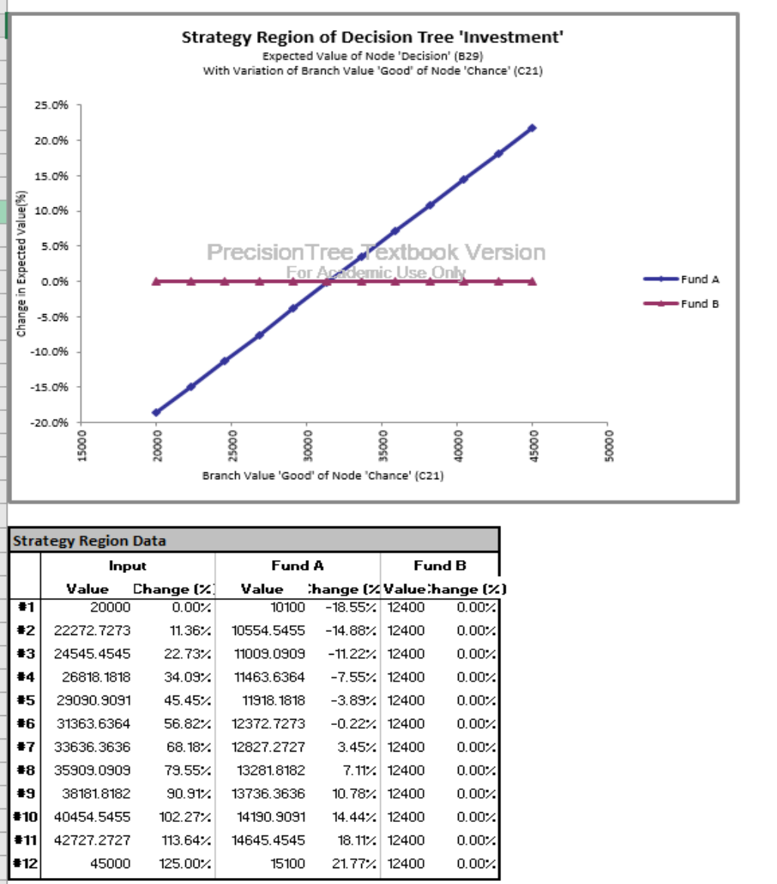

Sensitivity

### Cumulative Probability

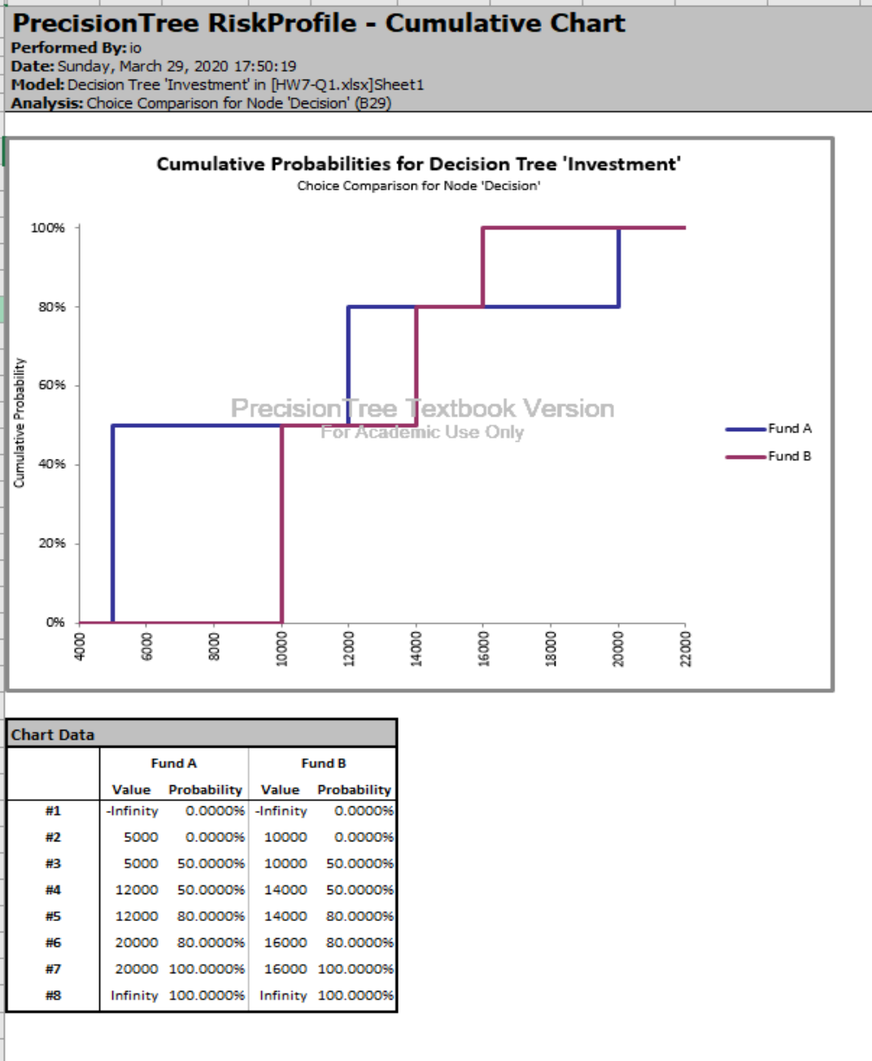

Q1 Cumulative Probability

* There is a %50 risk to end up loosing 5000K using Fund A strategy
* There is a %50 risk to end up with initial 10000K using Fund B strategy

### Spider

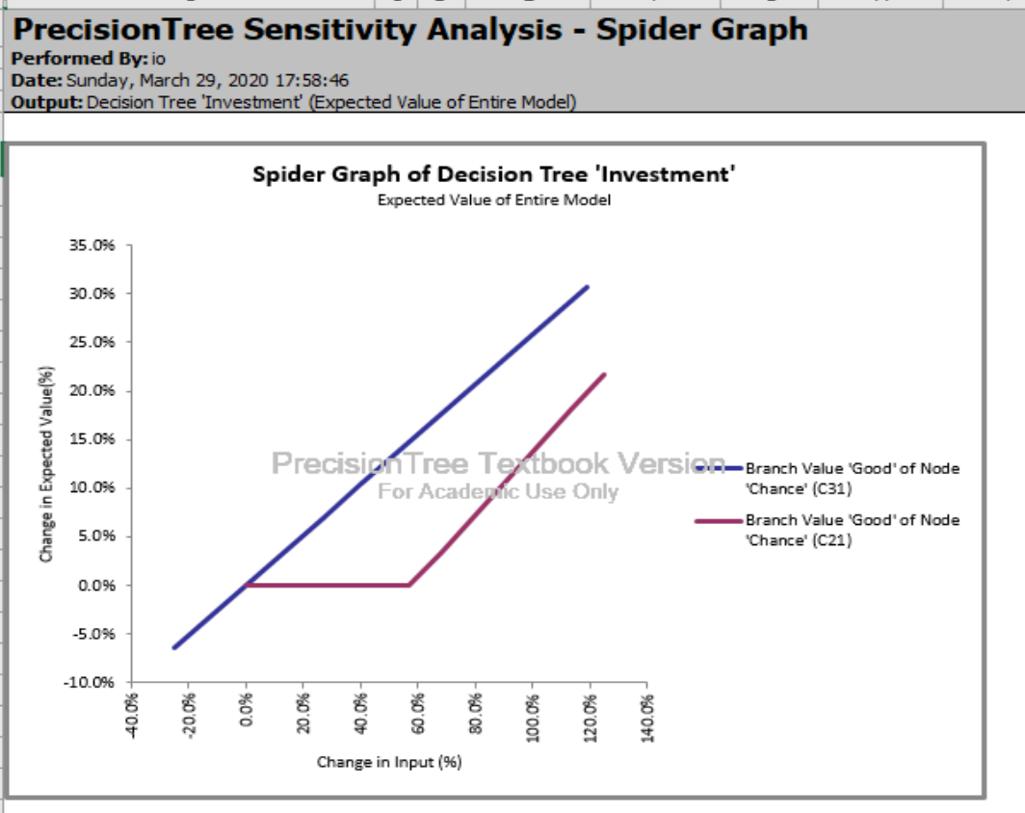

Q1-Spider

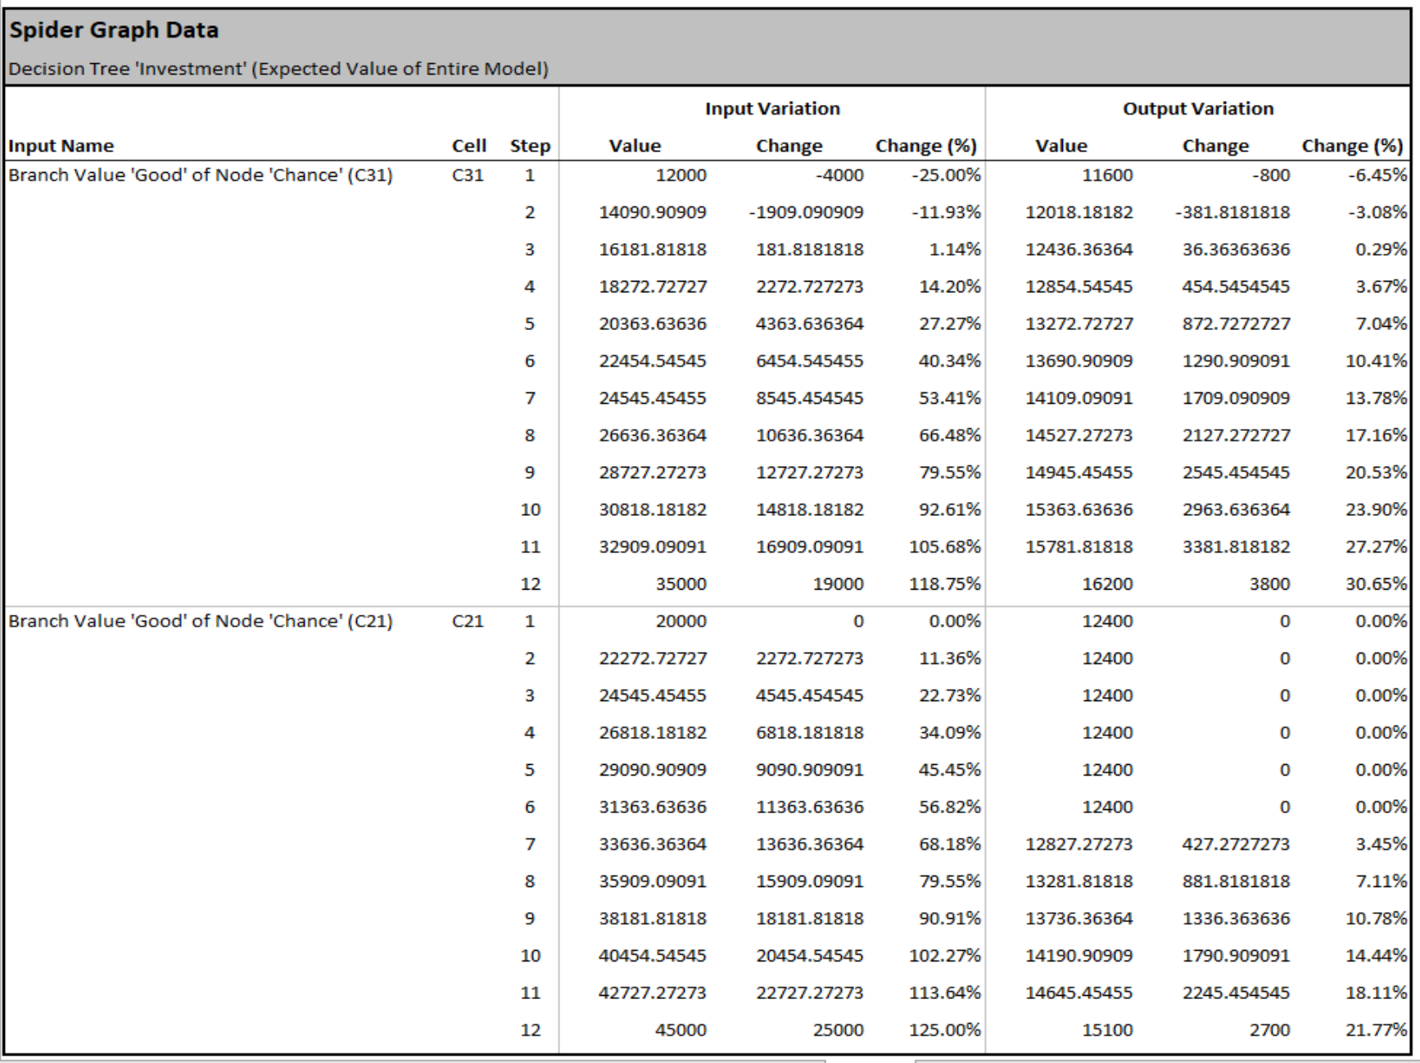

Q1-sp-data

### Tornado

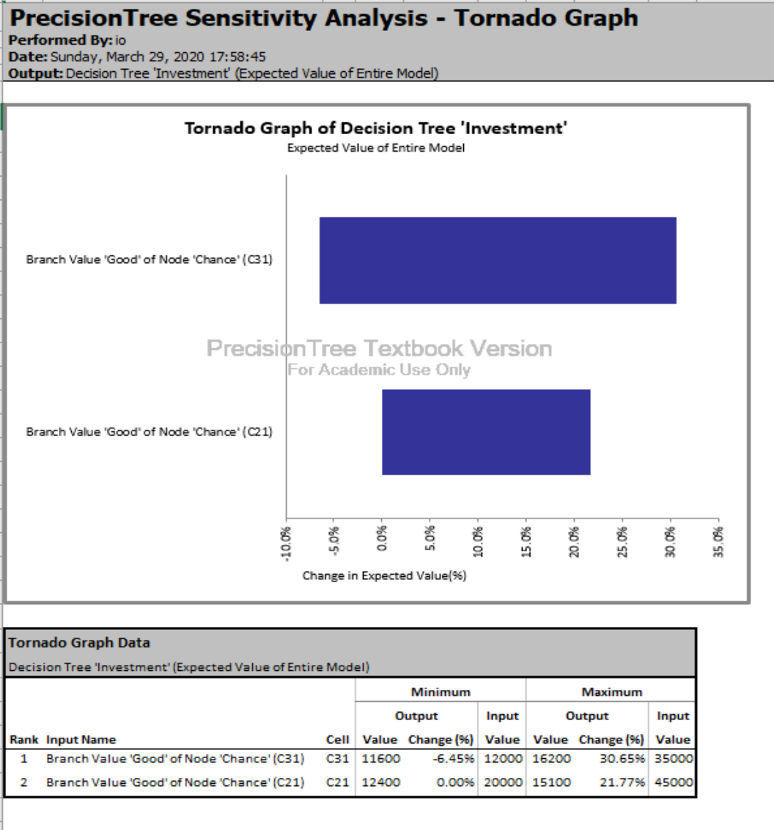

Q1-tornado

### Conclusions

* For the Fund A investment to become more valuable in the Good Economy scenario the return must be at least 21.5K
* There is an equal risk of ending up with 5000K less trusting the Fund A as wel as keeping the initial 10000K with investing in the Fund B

## Q2

The goal is to minmize the EMV of Support cost per episode

1. 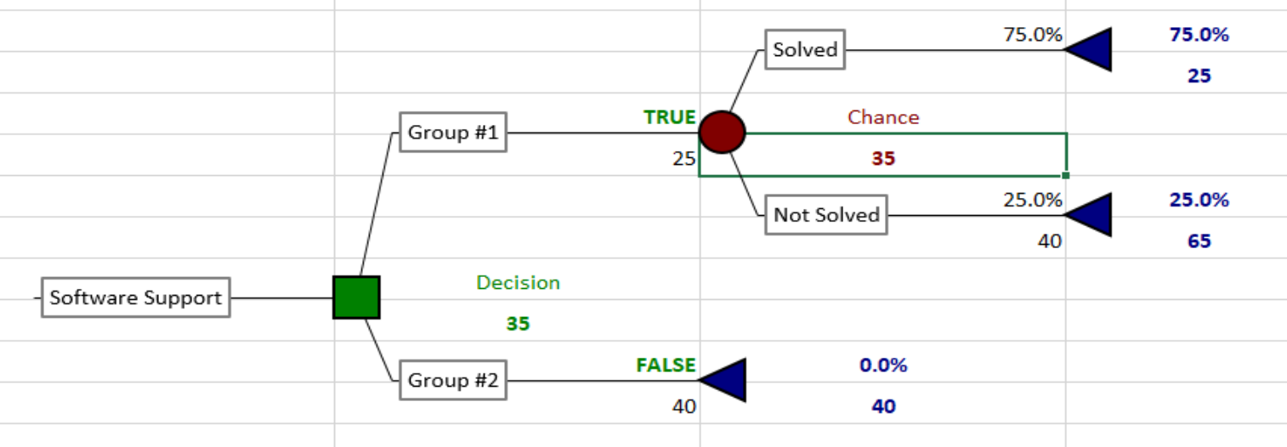
2. Q2-a
3. The assigment of Group 1 specialist in the case where probability of him solving the problem is 75% have EMV of $35 vs $40 if the Group 1 takes it first. The Group 1 has to handle this request.
4. 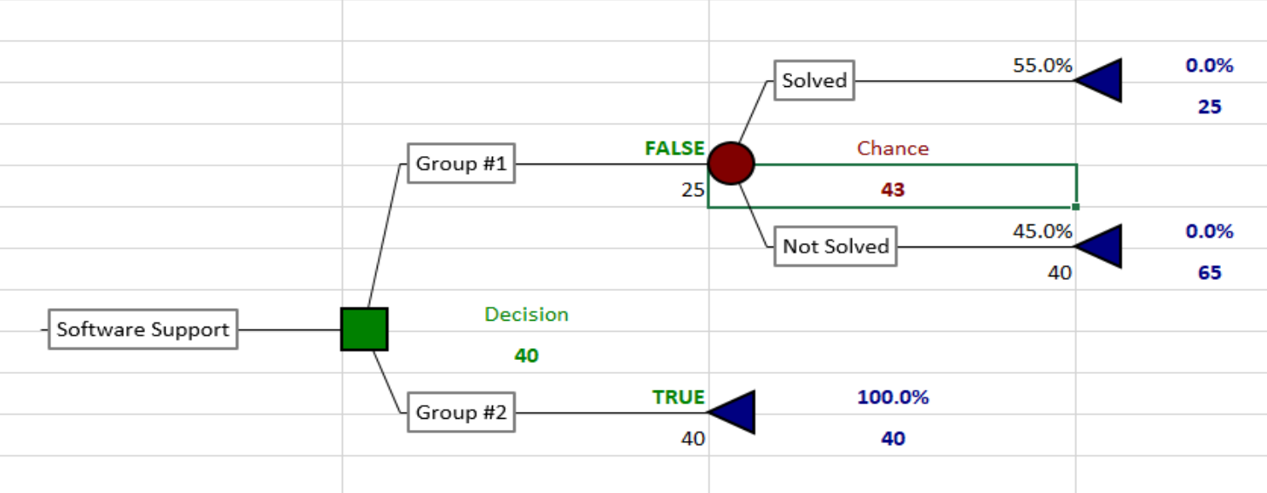
5. Q2-c
6. The assigment of Group 2 specialist in the case where probability of the Group 1 specialist solving the problem is 55% gives EMV of $40 vs $43 if done the other way. The Group 2 has to handle this request.
7. If Probability of solving assigment by Group 1 specialist is bellow 62.5% the problem has to be assigned to Group 2

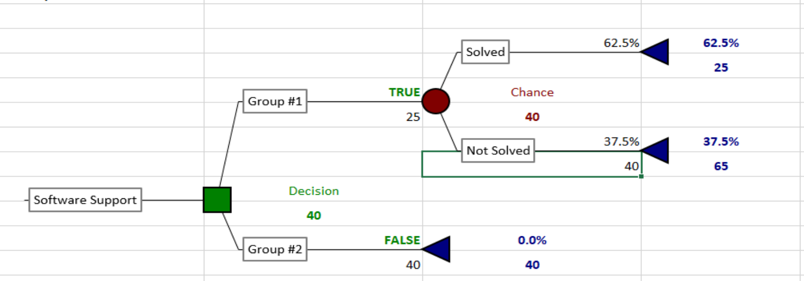

Q2-c

### 11.6.a)

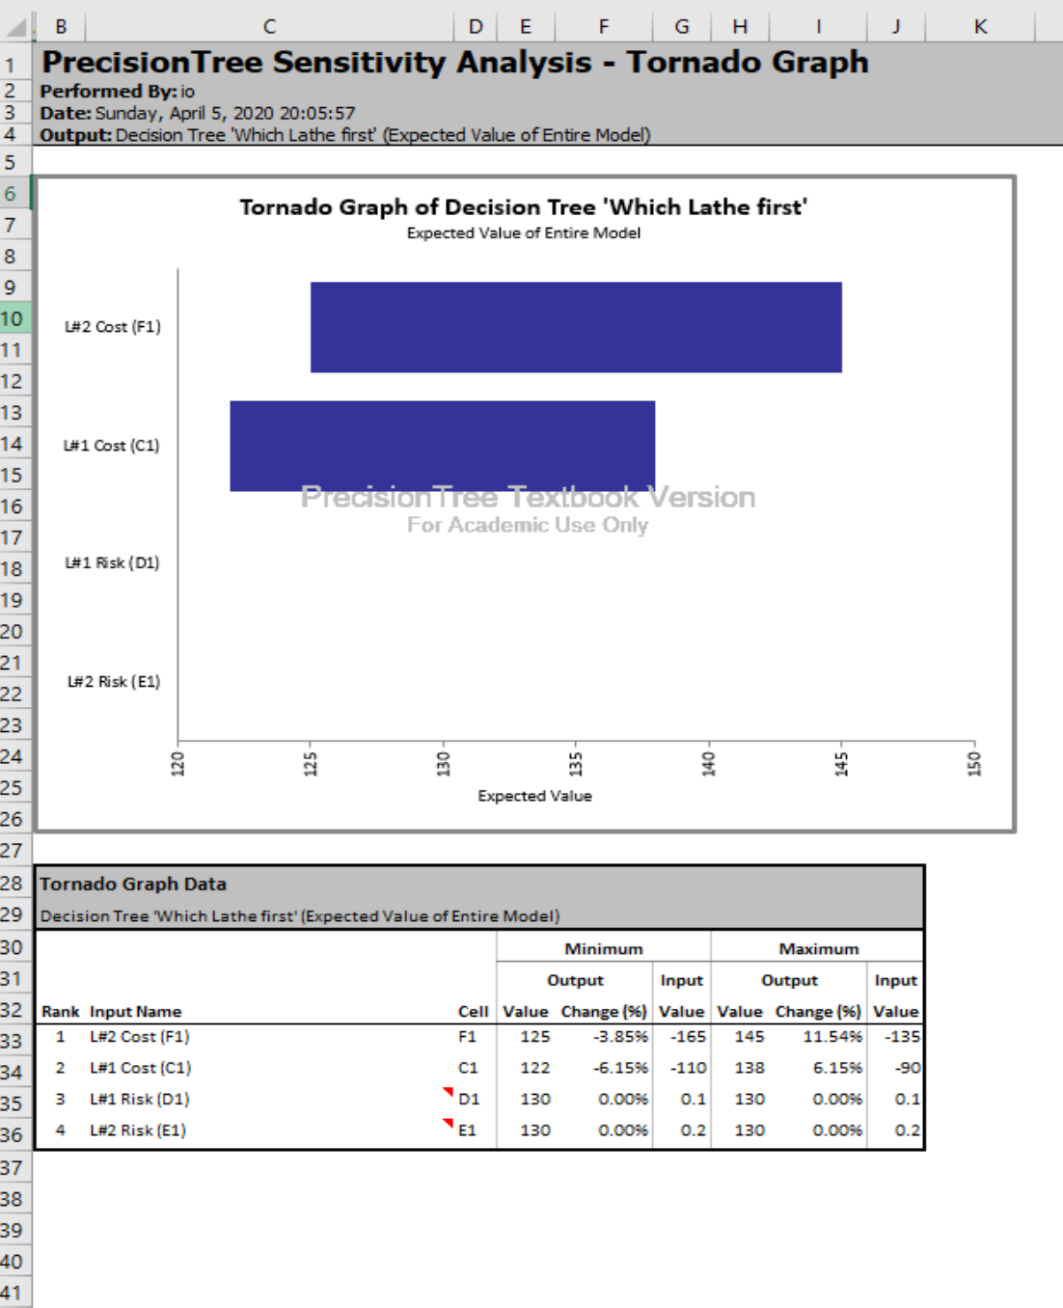

Q2

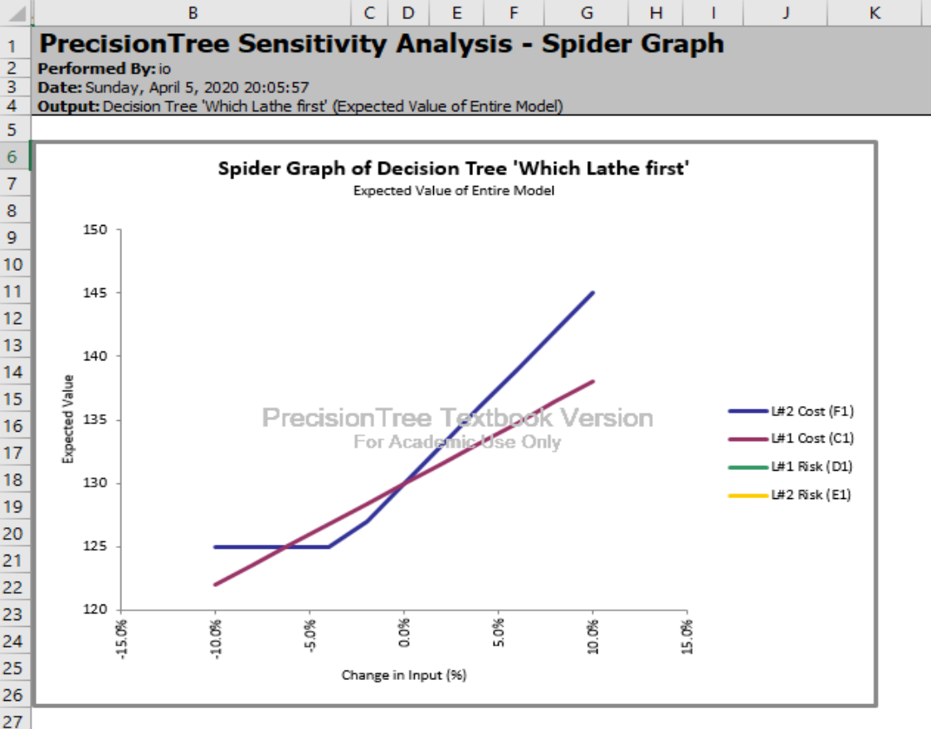

Q2

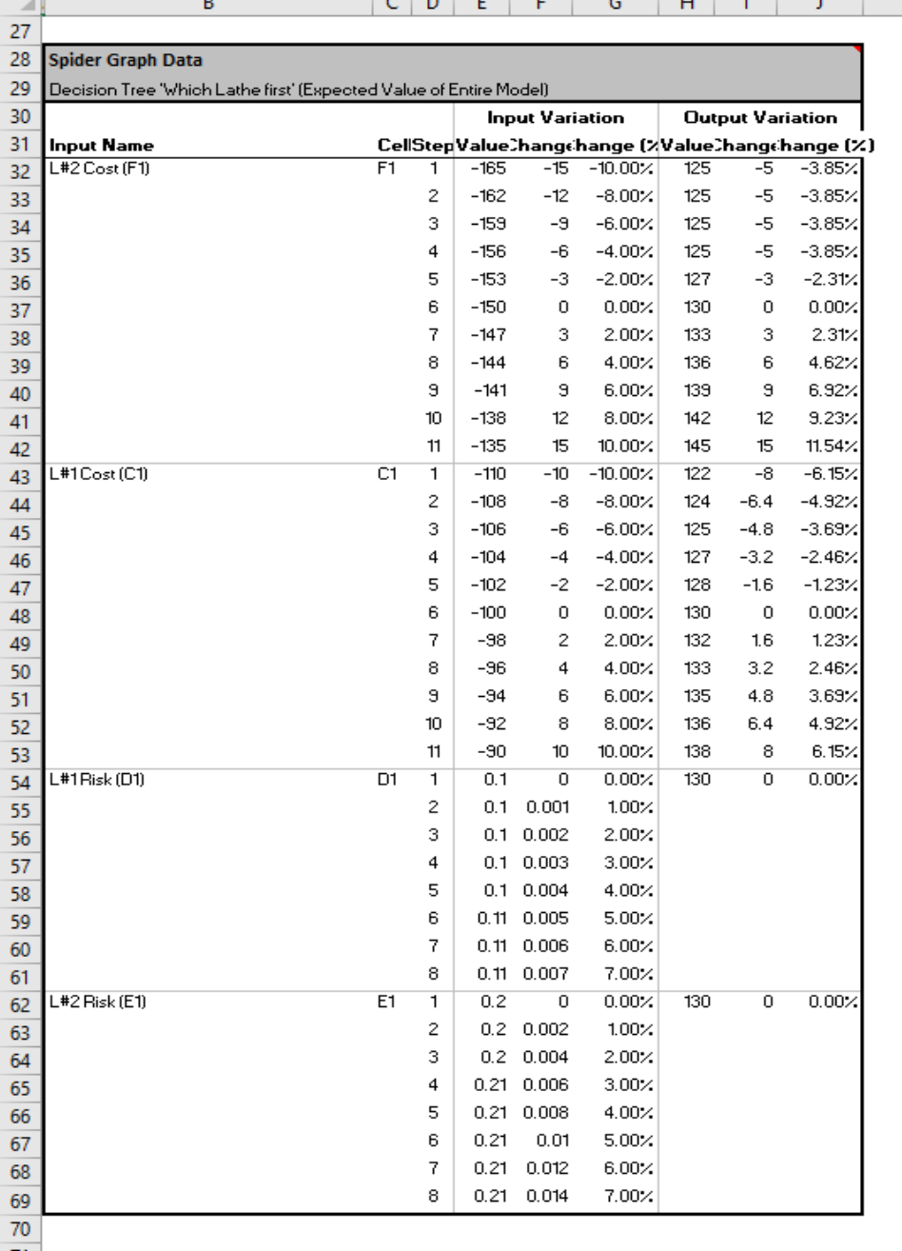

Q2

### 11.6.b)

* The *highes impact* is from L#2 Cost
* No impact from *Both* Risks

### 11.6.c)

* The highes *Rate of Change* is the L#2 Cost

### 11.6.d and 11.6.e)

The *Expected Value of Perfect Information* is calculated by taking the pessimistic value and subtracting the optimistic value.

For given range of changes:

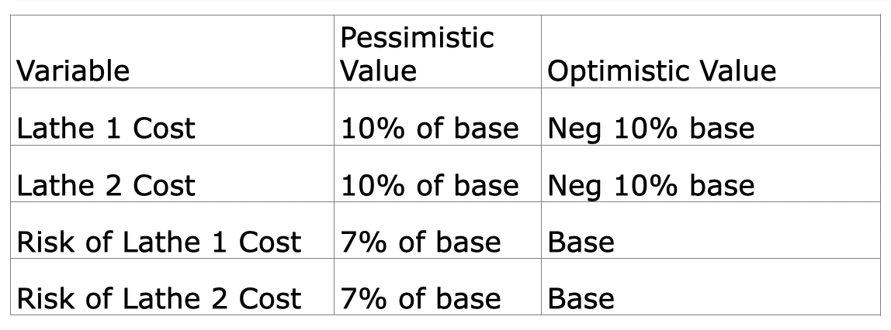

EVPI

The *EVPI*s for both are as follows:

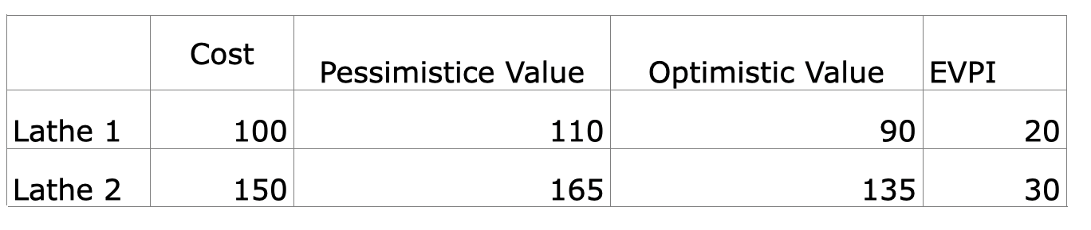

EVPI

## Q3

### a)

The Probability of part to be scrapped is the *same no matter what order the operations are performed*. * What is the probability of the part being ruined?

* Probability of Success (1 – 0.1)(1 – 0.2) = %72   
* Probability of Failure %100 - %72 = %28

### b) Q3 Tree

### c) Conclusion: Lathe #2 has to start first.

### d) The Total value encreases linearly with coefficient ~1 when cost of L#2 operation drops

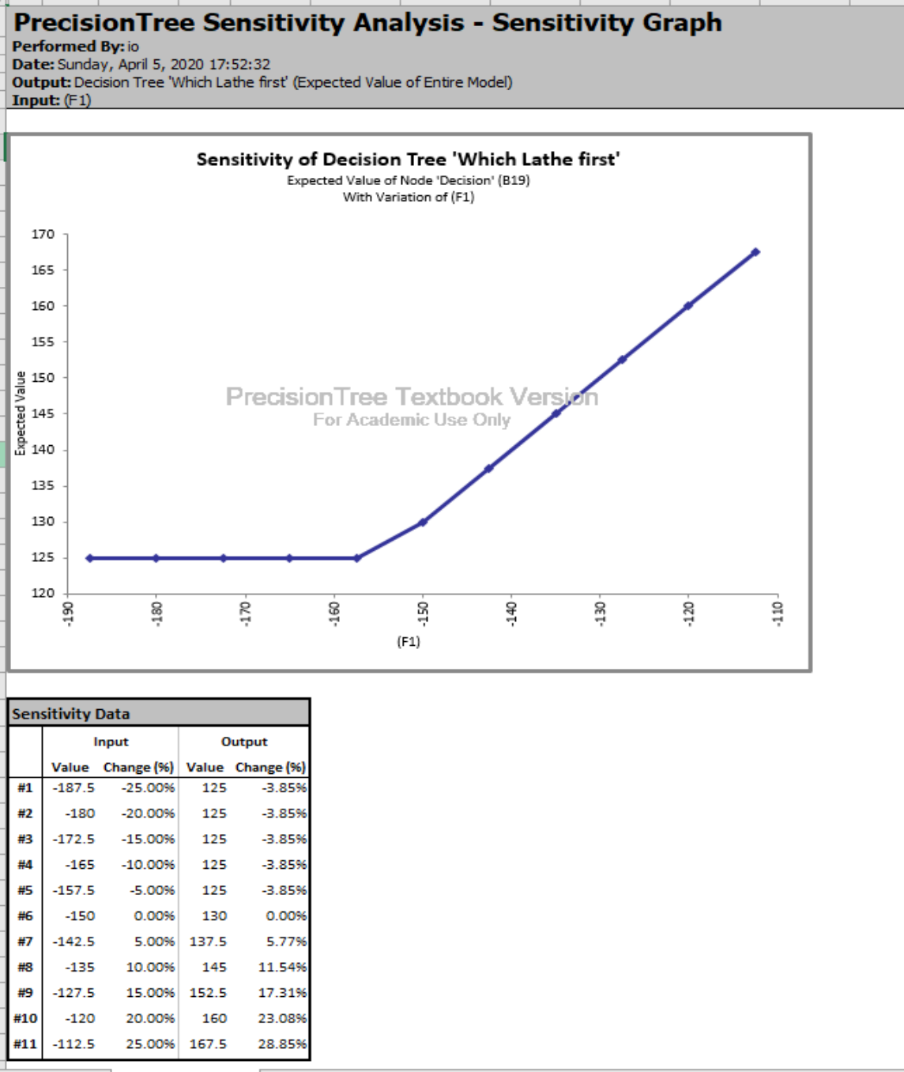

Q3 Tree

### 10.14.a) There is 3! = 3*2*1 or six possible permutations for the three machines.

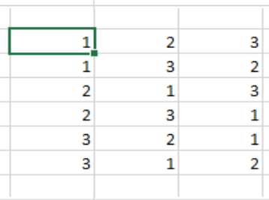

Q3 Tree

### 10.14.b)

* Probability of Success (1 – 0.1) * (1 – 0.2) * (1 - 0.25) = %54  
* Probability of Failure %100 - %54 = %46

### 10.14.c)

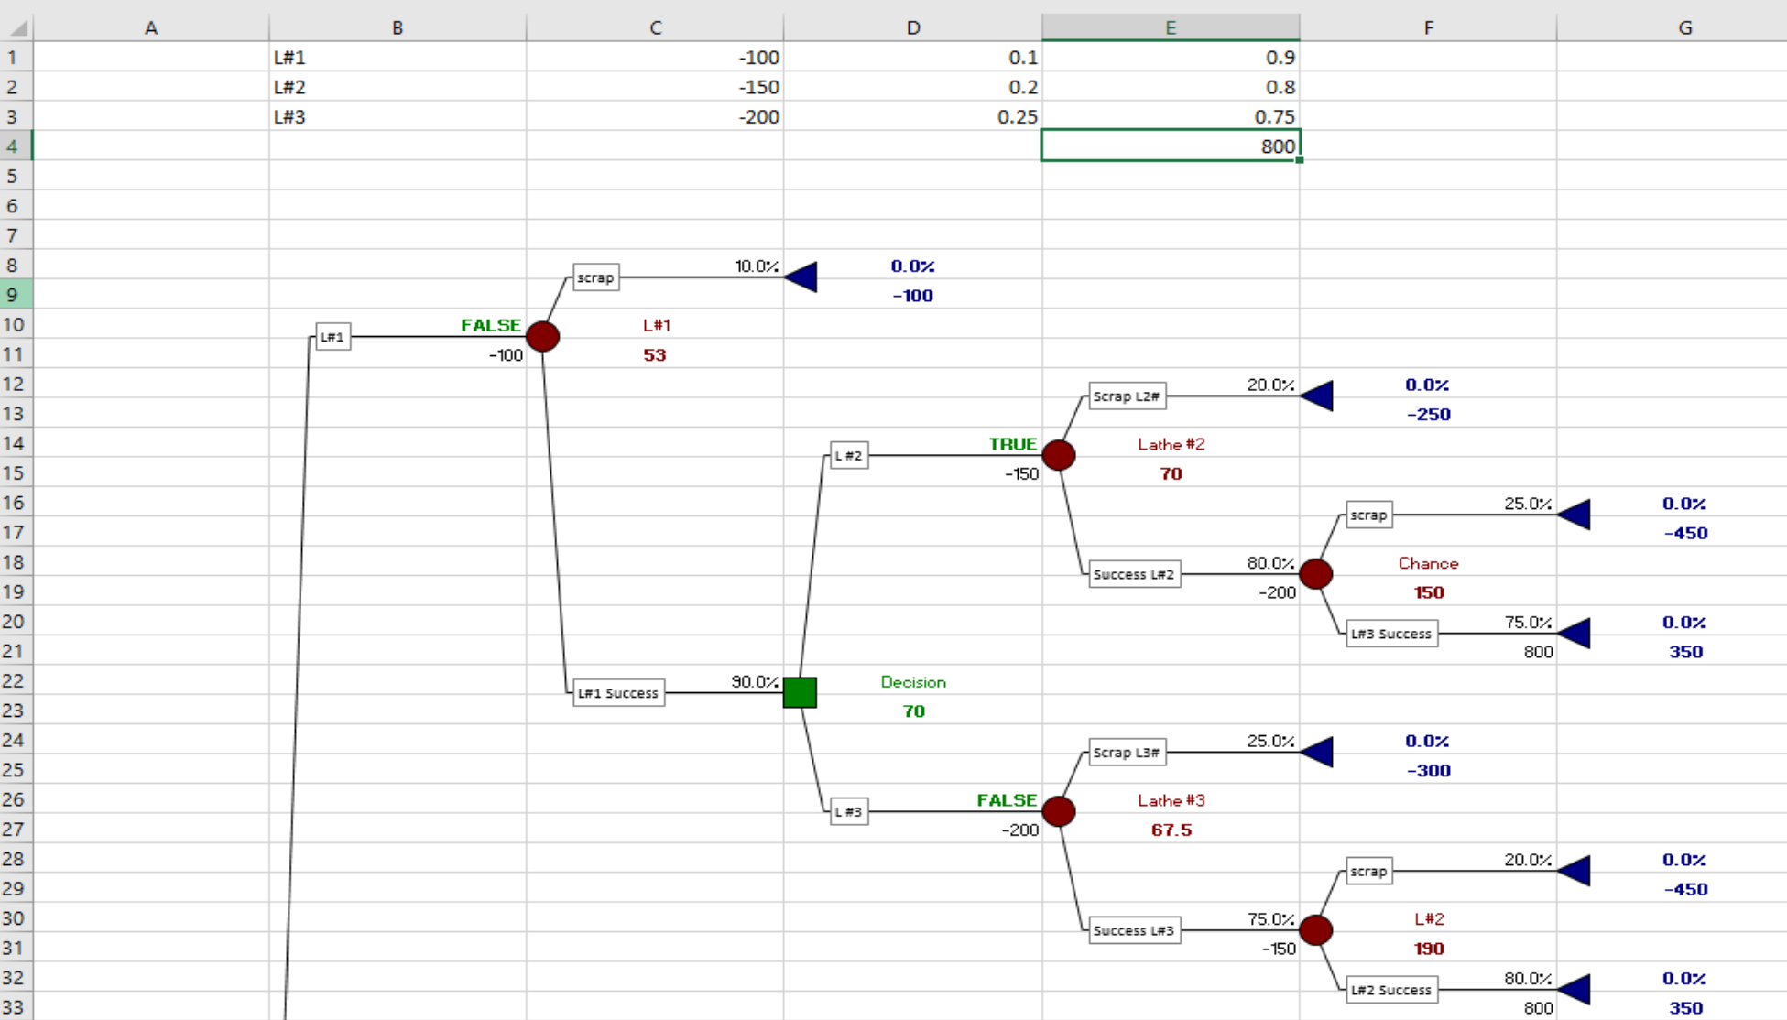 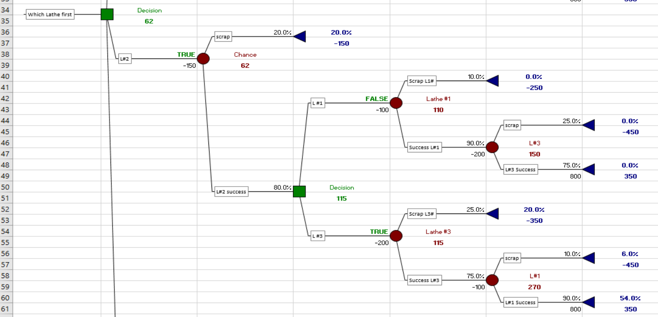 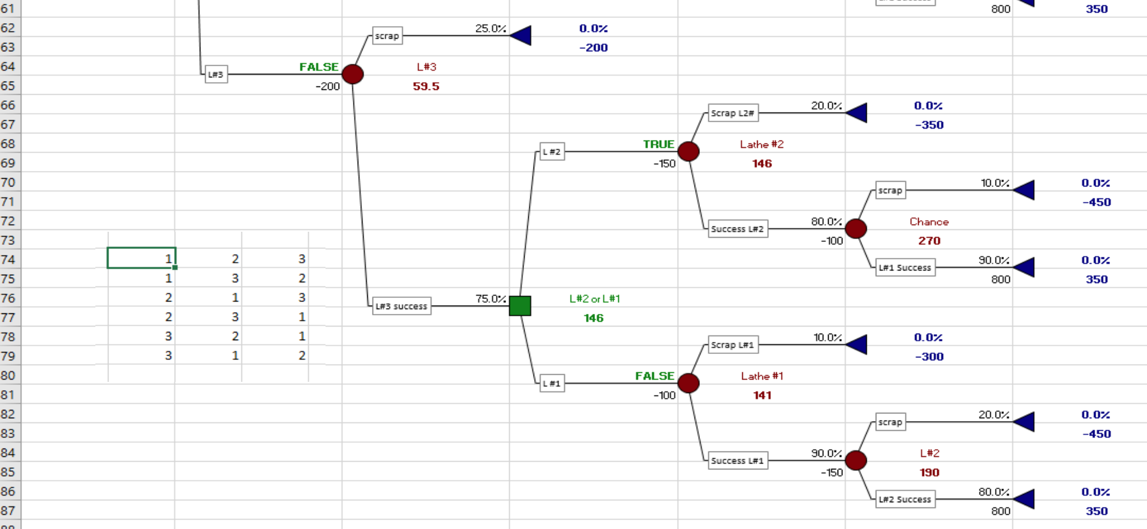

### 10.14.d)

The winning branch is L#2 -> L#3 -> L#1. The Value obtained is 62. The second choice in the L#3 -> L#1 -> L#2 =:= 59.5. It is possible to schedule the processing this way too if needed for the situation.

### 10.14.e)

For the pair-wise comparison one would build a table with 6 rows and calculate the value and select the maximum - the same calculations done during the Tree RollUp. Unfortunately the complexity grows very fast: it the function of n!!

### 10.14.f)

There is 4! = 4*3*2*1 or 24 permutations for the four machines.

### Conclusions

* There impact of the processing cost for step performed by Lathe#2 is the most significant for two-machines configuratiuon.
* Only two decisions needed for three-machines configuration.
* In some industries, like Aviation/Space, the loss of the part being scraped may significantly impact the Value: the complicated machining with high tolerances may bring the part costs to 100K range - this is most defenetely need to be taken into account in real life problems.
* The probability of scrap grows wth adding more steps to the processing.
* The fast increasing the number of possible permutations per added process impose some limit on the tree based models.